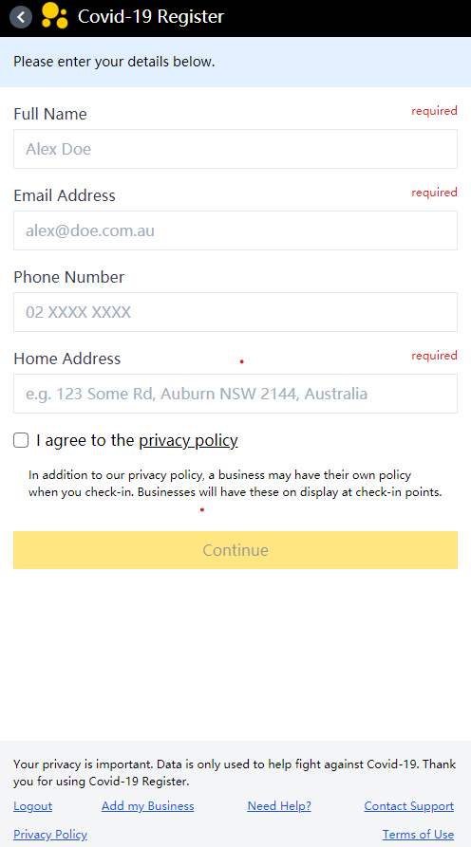

The first page is <https://au.covidregister.com/signup> ,when visiting the register page, the layout of the title and background in the header is very clear, highlighting the theme and logo of the page. The main function is register. The login information that users need to provide includes email and name, etc. Besides, our team is above the characteristics of this email login, It also provides a link that can sign up for users who currently have no account to log in easily for Covid-19 tracing,and client and server store information and send data here.

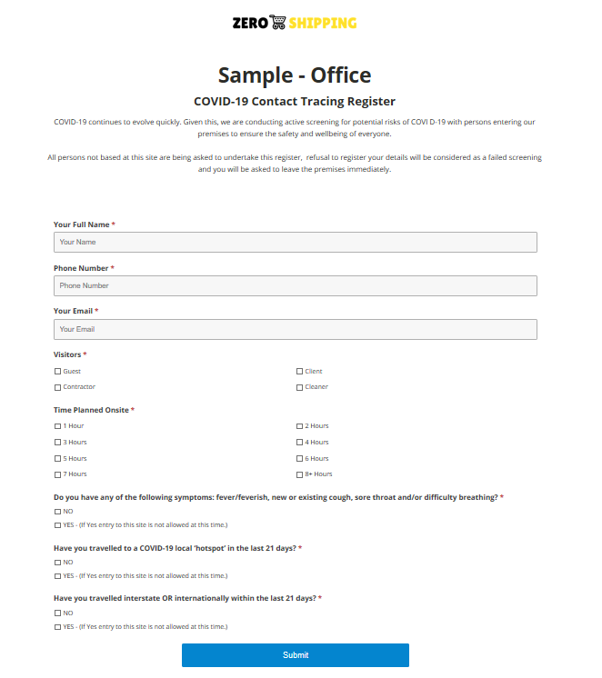

The other website we see is https://covidsaferegister.com.au/your-store/ which is similar to the register function of the first page. However, the difficulty of this page lies in the relatively large amount of information.For the simple login of users, a relatively clear way is to reduce the amount of reading.

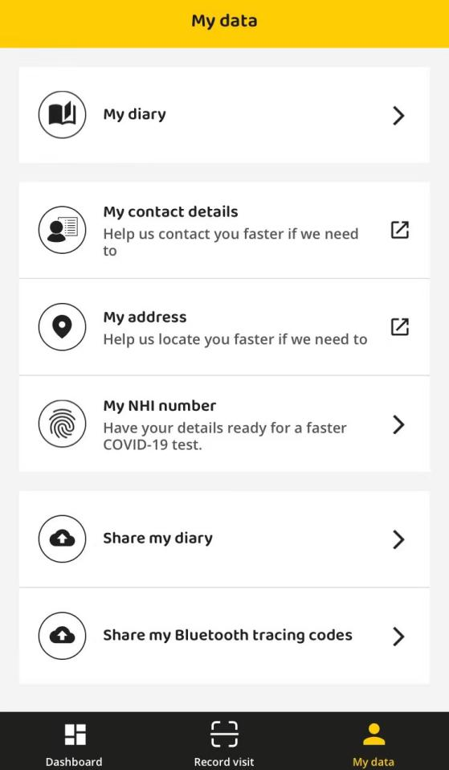

After the NZ COVID Tracer application users log in, they can manage their own information, change their name or address, contact number, street, etc. This is also the place where our database has relative.

 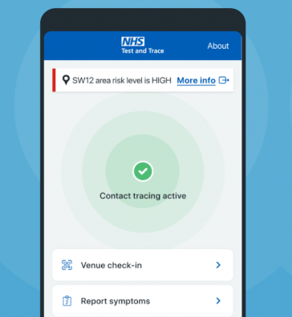

In another NHS test and trace application, we can also log in through the venue, query the login address through the page, effectively save the address that the user has been to, so as to facilitate the user to view the record. In our team's design, it is very convenient that admins can search ID and address to find the user's record.

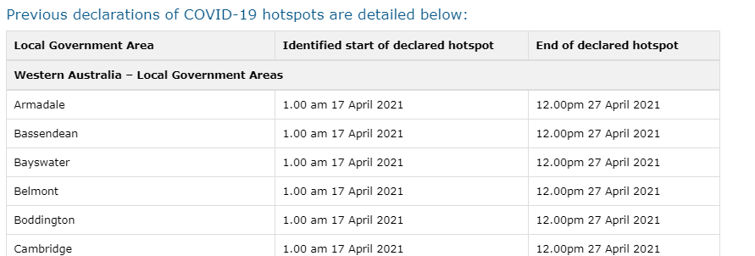

The next website is to record hotspots, https://www.health.qld.gov.au/system-governance/legislation/cho-public-health-directions-under-expanded-public-health-act-powers/declared-hotspots-direction.Because after each user records the location, if someone goes to the hospital and is diagnosed with the virus , our admins has the right to add the hotspot management system on the web page after logging in, In our team plan, admins can increase the location and time of recording hotspots, or select all or delete a hotspot individually.

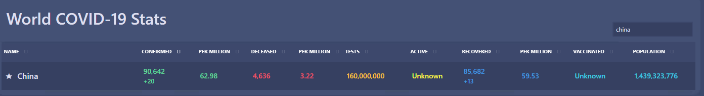

Finally, we're on this page https://ncov2019.live/ Open the function of the search box, and find that you can query information by keyword ID or location name, which is convenient for managers to manage and provide information about the epidemic situation. We search the name of the infected area with the search bar,so that theycan clearly know whether he has potential risk of infection.Through the setting of search country query information.

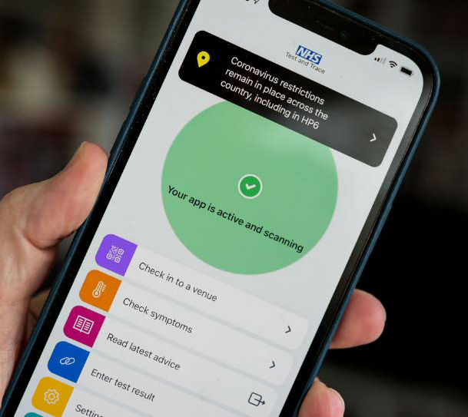

The first attraction of this page is the beauty and neatness of the whole page. The color of uniform saturation makes the page look very energetic and special. Put the function at the bottom, so that users can better touch the check-in with their fingers.

Therefor,that is part of our inspiration.